sTable 1: Laboratory Findings at Presentation
Test | Result at Presentation | Flag | Reference Range
Complete Blood Count
Hemoglobin (Hb) | 4.9 g/dL | Low | 13.0-17.7 g/dL
Hematocrit (Hct) | 19.1% | Low | 37.5-51.0%
Red Blood Cells (RBC) | 3.2 x10¹²/L | Low | 4.4-5.8 x10¹²/L
Mean Corpuscular Volume (MCV) | 59 fL | Low | 80-100 fL
Mean Corpuscular Hemoglobin (MCH) | 15.2 pg | Low | 26.6-33.0 pg
Mean Corpuscular Hb Conc. (MCHC) | 25.7 g/dL | Low | 31.5-35.7 g/dL
Red Cell Distribution Width (RDW) | 16.7% | High | 11.6-15.4%
Platelet Count | 550 x10⁹/L | High | 150-450 x10⁹/L
White Blood Cell Count | 9.8 x10⁹/L | Normal | 4.5-11.0 x10⁹/L
Iron Studies
Serum Ferritin | 8 ng/mL | Low | 30-400 ng/mL
Serum Iron | 28 µg/dL | Low | 65-175 µg/dL
Total Iron-Binding Capacity (TIBC) | 498 µg/dL | High | 250-400 µg/dL
Transferrin Saturation | 6% | Low | 20-50%
Other Relevant Labs
C-Reactive Protein (CRP) | 2.1 mg/L | Normal | <5.0 mg/L
Erythrocyte Sedimentation Rate (ESR) | 10 mm/hr | Normal | 0-15 mm/hr
Serum Carcinoembryonic Antigen (CEA) | 2.5 ng/mL | Normal | <5.0 ng/mL
Renal & Liver Function Tests | Within normal limits

sTable 2: Genes Analyzed in the Hereditary Gastrointestinal Cancer Panel
Gene | Transcript | Result | Associated Syndrome(s)
APC | NM_000038.5 | Pathogenic Variant Identified | Familial Adenomatous Polyposis
MUTYH | NM_001128425.1 | Negative | MUTYH-Associated Polyposis
STK11 | NM_000455.4 | Negative | Peutz-Jeghers Syndrome
SMAD4/BMPR1A | NM_005359.5/NM_004329.2 | Negative | Juvenile Polyposis Syndrome
PTEN |  | Negative | PTEN Hamartoma Syndrome
TP53 | NM_000546.5 | Negative | Li-Fraumeni Syndrome
MLH1, MSH2, MSH6, PMS2, EPCAM | NM_002439.4 | Negative | Lynch Syndrome
POLE, POLD1 | NM_006231.3/NM_002691.3 | Negative | Polymerase Proofreading-Associated Polyposis

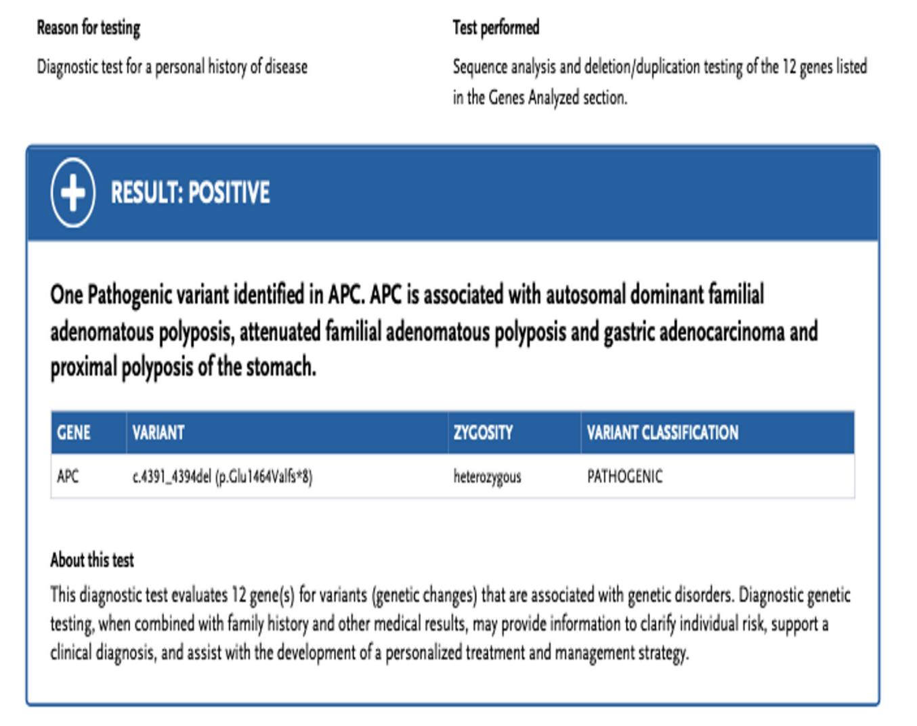
sFIGURE 1: Genetic Test Result Summary. Summary of genetic test results confirming a heterozygous pathogenic variant in the APC gene (c.4391_4394del; p.Glu1464Valfs8).

sTable 3: Hematologic and Iron Parameters at 6-Month Follow-up
Test | Result (6 Months Post-Op) | Result at Presentation | Comments
Hemoglobin (Hb) | 14.8 g/dL | 4.9 g/dL | Normalized
Mean Corpuscular Volume (MCV) | 88 fL | 59 fL | Normocytic
Serum Ferritin | 65 ng/mL | 8 ng/mL | Replenished stores
Transferrin Saturation | 28% | 6% | Normal

