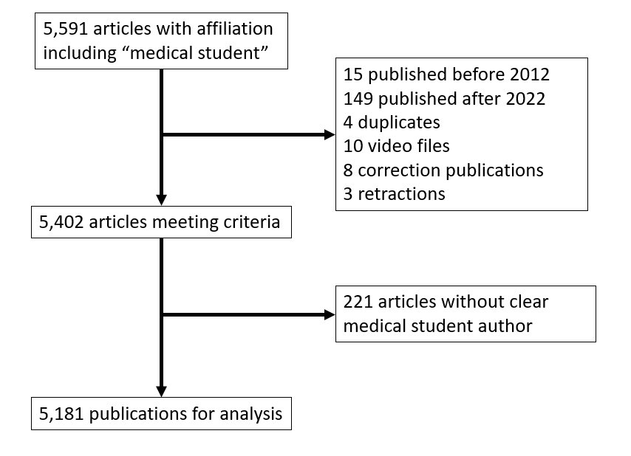
Supplemental Figure 1. Flow diagram of article inclusion and exclusion.

Supplemental Figure 2. The proportion of medical student-authored publications with zero citations from 2012 to 2022.
Supplemental Figure 3. The percentage of total publications published in a journal that was one of the top 100 most common and had a mandatory associated cost with publishing.

