Rule 1: Please do not re-order the excel file. It will make it much easier to copy and paste everyone’s data into.
Feel free to adjust row/column sizes, freeze panes, or similar viewing options to make it easier though.

Step 1: Manual citation counts
Column AE is where we will be putting these. Cells highlighted in yellow need manual collection of citation counts.
We’ll divvy them up so I will get rows 4723 to 5000
Zach will get 5001 to 5250
Evan will get 5251 to 5413 (end)
How to do it:
- Copy and paste the article title (Column E) into the search bar at www.semanticscholar.org
- If the article has citations, it will appear next to the quotes as below. This article has 11 citations.
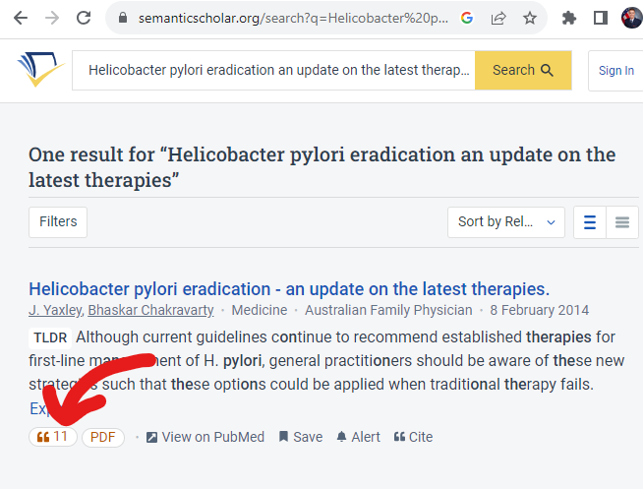
- Put the number in column AE (in this case, 11). If an article has 0 citations but is in semantic scholar, put 0. If an article is not in semantic scholar at all, leave blank
This part should be very quick because it’s just copy and pasting quickly. Once you’re finished, complete step 2 up to “4.” And email me your data sheet.

Step 2: Article data collection
There is a science to doing data collection, if you’re interested, here is an article that goes through more detail: https://www.ncbi.nlm.nih.gov/pmc/articles/PMC3853868/. But I’ll sum up some of it with our procedure plan.
We will be putting the study design data in column L
- Here are the design options I’ve narrowed it down to:
case report (single, case series, or case with review)
review (either general or systematic)
perspective (anything opinion, perspective, editorial, etc)
med-ed intervention (most will be in the journals academic medicine and mededportal, but these include anything regarding education)
Cross-sectional – snapshot in time, often surveys
Case-control – a group of people who have an outcome compared with controls that do not
Retrospective cohort – a group of people who do not have an outcome that are followed
prospective observational (typically prospective cohort studies, a retrospective analysis of prospectively maintained data such as large registries does NOT count)
interventional (RCT)- probably few, doesn’t have to be randomized but DOES have to be clinical trial. They should specifically say this.
lab experiment- anything benchwork, rats, etc.
other (please try to use this as little as possible, it should be definitively not applying to other categories. An example would be historical research or something like that)
- There are plenty of resources on the internet that go through study designs, but just be sure to ask if you have any questions!
- It is very important that you use the dropdown menu to select the study design, otherwise it won’t be easy to analyze.
- How to assess the study design
  - Refer to the article title (column E), does it clearly signify the study design? If yes, list, if no, continue.
  - Refer to the abstract (which was auto-pulled for many articles into column K). Does it clearly signify the study design (typically in the abstract methods by either listing or describing the study design). If not available, will need to look up in pubmed for the abstract.
  - If not clear at this point, will need to review the full article for clarity.
  - If still unclear, please reach out to me.
- To start, everyone will list a design for the articles in rows 4948, 4080, 4383, 2753, 3609, 2321, 3608, 1242, 699, 306. Then email me your Excel file. Why would we all do the same charts? Great question. Because this is a more muddled assessment, we need to make sure we’re all on the same page. This is the pilot, I’ll review everyone’s answers and calculate a kappa (a statistical parameter that measures inter-relater reliability). As long as everything looks good at this point, I’ll give everyone the okay to continue.
- Then, I’ll do rows 1-1800. Evan will do rows 1801-3600. Zach will do 3601-end.
- Once you are about halfway through, please email me your Excel doc and I’ll do a quick monitor and then give you the go-ahead to continue.
- Above all, please feel free to reach out with questions!

