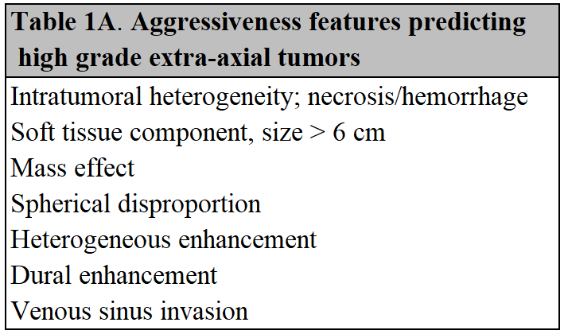
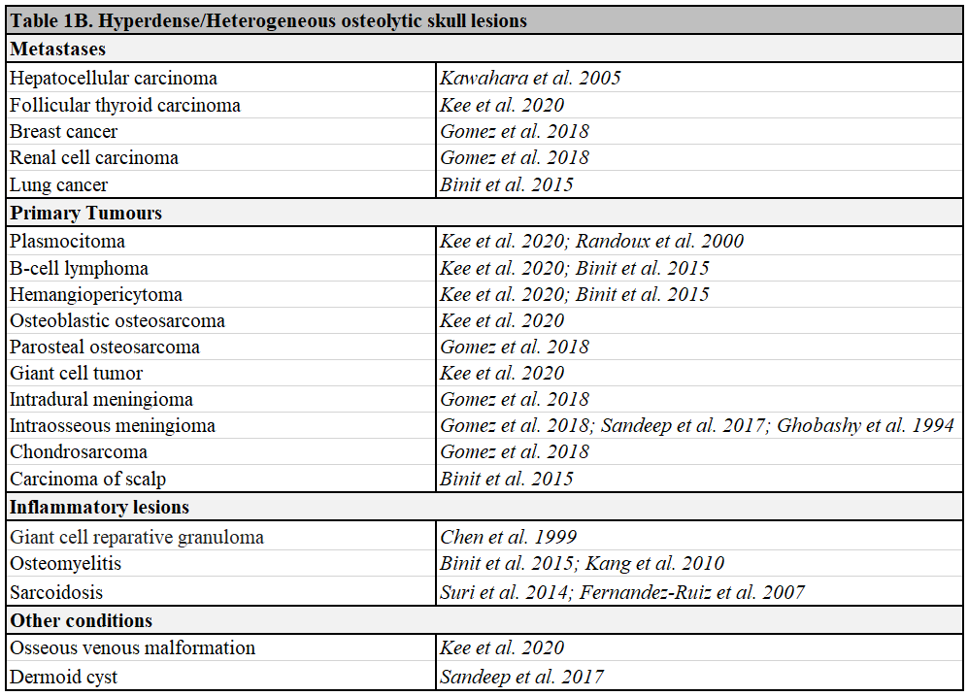
Table 1B References.
Binit S, Mittal MK, Mittal A, Thukral BB (2015) Atypical lytic lesions of skull: Clinical and radiological correlation. Annals of Indian Academy of Neurology. Jan-Mar;18(1):117-9. doi: 10.4103/0972-2327.144309
Chen SS, Chiang JH, Chang CY, Lao CB, Lirng JF, Teng MM (1999) Giant cell reparative granuloma: a case report. Zhonghua Yi Xue Za Zhi (Taipei). Oct;62(10):738-42
Kang SH, Park SW, Kwon KY, Hong WJ (2010) A solitary skull lesion of syphilitic osteomyelitis. Journal of Korean Neurosurgical Society. Jul;48(1):85-7. doi: 10.3340/jkns.2010.48.1.85. Epub 2010 Jul 31
Fernández-Ruiz M, Guerra-Vales JM, Castelbón-Fernández FJ, Llenas-García J, Rodríguez-Peralto JL, López-Lancho R, Redondo-Marcos I (2007) Sarcoidosis presenting as an osteolytic skull lesion: a case report and review of literature on skull sarcoidosis. Clinical Rheumatology. Oct;26(10):1745-8. doi: 10.1007/s10067-006-0497-6. Epub 2007 Jan 3
Ghobashy A, Tobler W (1994) Intraosseous calvarial meningioma of the skull presenting as a solitary osteolytic skull lesion: case report and review of the literature. Acta Neurochirurgica (Wien). 129(1-2):105-8. doi: 10.1007/BF01400883
Gomez CK, Schiffman SR, Bhatt AA (2018) Radiological review of skull lesions. Insights Imaging. Oct;9(5):857-882. doi: 10.1007/s13244-018-0643-0
Kawahara I, Tsutsumi K, Hirose M, Matsuo Y, Yokohama H (2005) Skull metastasis of hepatocellular carcinoma: case report. No Shinkei Geka. Sep;33(9):903-9
Kee TP, Liauw L, Sathiyamoorthy S, Lee HY, Tan GSL, Yu WY (2020) Large solitary lytic skull vault lesions in adults: radiological review with pathological correlation. Clinical Imaging. Feb;59(2):129-143.doi: 10.1016/j.clinimag.2019.10.011. Epub 2019 Nov 27
Randoux B, Nataf F, Meary E, Meder JF, Fredy D (2000) Solitary plasmocytoma of the calvarium. Journal of Neuroradiology. Dec;27(4):278-81
Sandeep BV, Banga MS, Saha SK, Roy K (2017) Osteolytic Skull Lesions–Our experience. Journal of Neurosciences in Rural Practice. 8:434-8
Suri V, Singh A, Das R, Das A, Malhotra P, Jain S, Kumari S, Khandelwal N, Varma S (2014) Osseous sarcoid with lytic lesions in skull. Rheumatology International. Apr;34(4):579-82. doi: 10.1007/s00296-013-2752-x. Epub 2013 Apr 23
Table 2A. PRISMA-style systematic case-finding review (For methodological details, see the Supplementary Data).
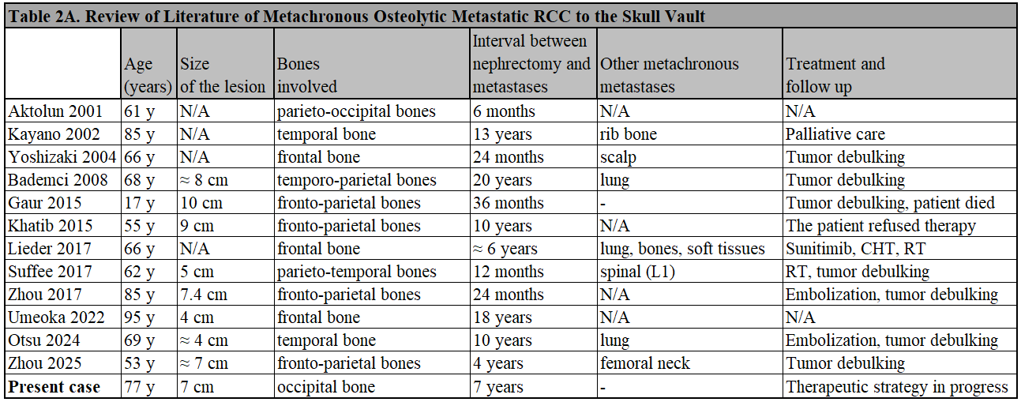
Supplementary Data. Systematic case-finding review - Methods. To substantiate the rarity of metachronous calvarial (cranial-vault) metastasis from clear-cell renal cell carcinoma (ccRCC), we conducted a systematic literature search in accordance with the PRISMA 2020 statement. Five databases were searched from inception to 11 June 2026: PubMed/MEDLINE (searched 7 June 2026), Scopus (9 June 2026), Web of Science Core Collection (10 June 2026), Europe PMC (10 June 2026) and the Cochrane Library (11 June 2026). The search combined three concept blocks — renal cell carcinoma (including the historical synonyms hypernephroma and Grawitz tumour), skull/cranial vault, and metastasis — using both controlled vocabulary and free-text terms, deliberately favouring sensitivity at the search stage and applying the restrictive criteria (exact site and timing) at the selection stage. Eligibility criteria were: (i) histologically confirmed renal cell carcinoma; (ii) metastasis to the cranial vault (calvaria) only, with the skull base and brain parenchyma excluded; and (iii) a metachronous presentation, defined as a metastasis diagnosed at least 6 months after the primary tumour. No date or language restrictions were applied. Records published in English and Italian were assessed directly by the authors; records in any other language — including Japanese, French, Spanish, German, Czech, Chinese and Russian — were assessed with the aid of machine translation, so that no record was excluded on the basis of language alone. Translation of records not published in English or Italian was performed with the assistance of a large language model (Claude, Anthropic). The tool was used exclusively for translation; all eligibility assessments and inclusion/exclusion decisions were made solely by the authors. The search yielded 1,321 records (PubMed, 392; Scopus, 459; Web of Science, 236; Europe PMC, 234; Cochrane Library, 0 reviews and 3 non-pertinent CENTRAL records). After removal of 596 duplicates (matched on PMID, DOI and title), 725 unique records were screened by title and abstract independently by two authors, with disagreements resolved by discussion; 685 records were excluded at this stage. Forty reports were sought for full-text retrieval, of which one could not be retrieved. Of the 39 reports assessed for eligibility, 27 were excluded with reasons (site not the cranial vault, n = 10; non-metachronous presentation, n = 12; different histological subtype, n = 2; temporal relationship to the primary tumour not specified, n = 3; this last group comprised three conference abstracts). Twelve articles, reporting 12 cases, met all eligibility criteria and were included. The database search was complemented by backward and forward citation searching of all 12 included articles, performed in Scopus, Web of Science and Google Scholar. After deduplication against the 725 screened records, citation searching yielded no additional eligible cases. Including the present case, this review identified 12 reported cases of metachronous calvarial-vault metastasis from ccRCC, confirming the rarity of this presentation through a reproducible and language-inclusive search. The present case, arising 7 years after radical nephrectomy for a pT1b, grade 2 tumour, adds to this limited subset and indicates that late calvarial recurrence may occur even after a low-stage primary.
Acknowledgements: Interlibrary-loan and document-delivery services were provided by the Biblioteca Centrale “Claudio Malaguzzi Valeri” – Polo Medico-Veterinario, Facoltà di Medicina e Chirurgia, Università degli Studi di Bari “Aldo Moro”.
References:
Aktolun C, Berk F, Demir H (2001) Detection of cold bone metastasis by Tc-99m MIBI imaging. Annals of Nuclear Medicine, Vol. 15, No. 4, 393-395
Bademci G, Berdan F, Evliyaoglu C (2008) Extremely delayed renal cell carcinoma metastasis mimicking convexity meningioma. Turkish Neurosurgery. Vol:18, No. 4, 400-403
Gaur K, Mandal S, Gondal R and Singh D (2015) Atypical Presentation of Calvarial Metastasis of Renal Cell Carcinoma in an Adolescent. A Rare Case Diagnosed on Fine Needle Aspiration Cytology With Literature Review. Diagnostic Cytopathology. Vol. 43, No 5 412-415
Kayano K, Murakami Y (2002) Temporal Bone Metastasis of Renal Cell Carcinoma: A Case Report. Practica Oto-Rhino-Laryngologica (Jibi Rinsho) 95(8):793–798. DOI: 10.5631/jibirin.95.793
Khatib Y, Momin E, Patel RD, Kamat A (2015) Cytodiagnosis of calvarial metastasis of renal cell carcinoma masquerading as a cavernous hemangioma after a long latency. Clinical Cancer Investigation Journal. March-April 2014, Vol. 4, issue 2, 263-265
Lieder A, Guenzel T, Lebentrau S, Schneider C, Franzen A (2017) Diagnostic relevance of metastatic renal cell carcinoma in the head and neck: An evaluation of 22 cases in 671 patients. International Brazilian Journal of Urology. Vol. 43 (2): 202-208, March - April doi: 10.1590/S1677-5538.IBJU.2015.0665
Otsu Y, Yamashita S, Kuramoto T, Shimamatsu K, Morioka M (2024) Metastatic temporal bone tumor from renal cell carcinoma coexisting with sphenoid ridge meningioma: a case report. Cureus 16(11): e73198. Doi 10.7759/cureus.73198
Suffee T, Derder M, Quilichini J, Dezamis E, Lantieri L (2017) Calvarial metastasis of renal cell carcinoma. BMJ Supportive & Palliative Care; 0:1-3. Doi:10.1136/bmjspcare-2016-001216
Umeoka A, Aso S (2022) Delayed metastasis of renal cell carcinoma. Internal Medicine (Japan). 61:2087-2088
Yoshizaki T, Honma Y, Hatayama N, Nonaka S, Harabuchi Y (2004) Recurrent Head and Neck Metastases of Renal Cell Carcinoma. Jibi Inkoka Rinsho 97(5):451–454
Zhou MH, Dunn GP, Osbun JW, Cross DT, Moran CJ, Dacey RG, Kansagra AP (2017) Direct puncture Onyx embolization of a large calvarial metastasis with intracranial extension: care report. Interventional Neuroradiology. Vol. 24(2) 220-224
Zhou J, Wu Y, Feng D, Wang S, Qin H, Li J, Yang D (2025) Surgical treatment and clinical evaluation of calvarial metastases. The Journal of Craniofacial Surgery. Vol. 36, Number 1, January/February, e55-e61

Table 2B. Characterization of the original renal cell carcinoma
- Left Kidney
- Primary tumor histologic subtype: Clear Cell Renal Cell Carcinoma (ccRCC). Immunohistochemistry: CK+, RCC+, CD10+, Vimentin+, CK7-, CD117-
- Stage T1b (5.5 x 4.3 cm, limited to the kidney; cortico-medullary extension, without invasion of the renal vein, perirenal fat, capsule, ureter or lymph nodes). No sarcomatoid/rhabdoid features. Focal necrotic and hemorrhagic areas
- Grade G2 (WHO/ISUP. Nuclei slightly larger and more irregular; nucleoli visible at intermediate magnification): low-to-intermediate risk of metastasis

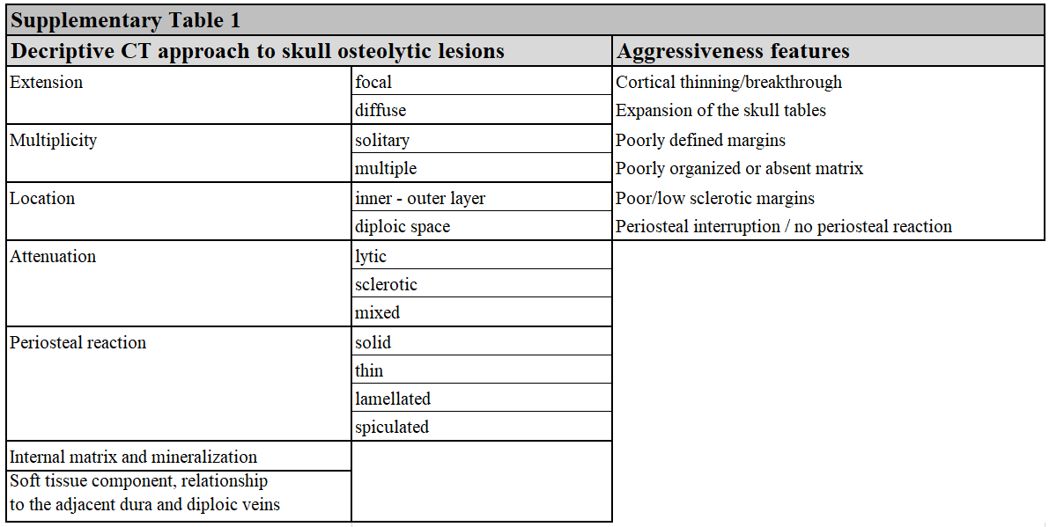

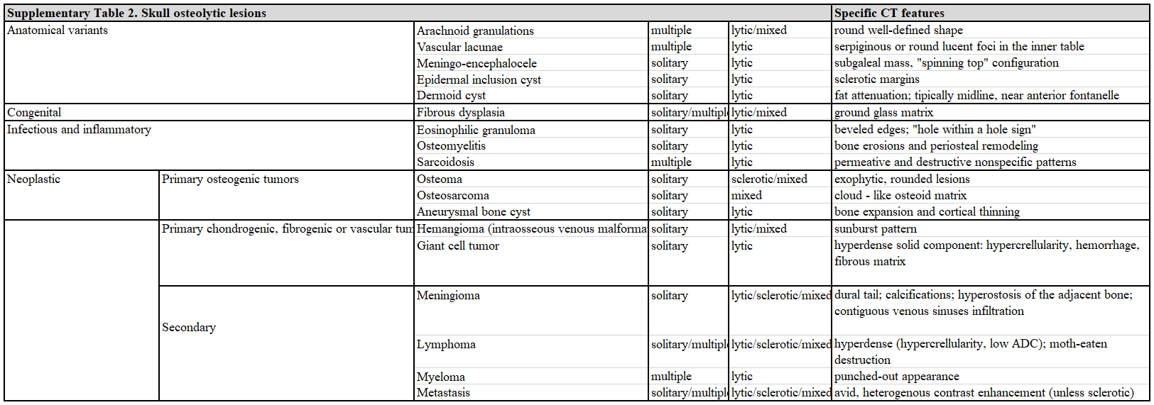

Supplementary Table 1 and Supplementary Table 2.
References.
Michael CB, Gokaslan ZL, DeMonte F, McCutcheon IE, Sawaya R, Lang FF (2001) Surgical Resection of Calvarial Metastases Overlying Dural Sinuses. Neurosurgery. Vol. 48, No. 4, April
Rekhi B, Kumar R, Menon S, Medhi S, Desai SB (2009) Calvarial Metastasis of a Renal Cell Carcinoma, Mimicking a Primary Alveolar Soft Part Sarcoma, in a Young Girl—a Rare Case Report. Pathology & Oncology Research. 15:137–141 DOI 10.1007/s12253-008-9097-x
Gaur K, Mandal S, Gondal R and Singh D (2015) Atypical Presentation of Calvarial Metastasis of Renal Cell Carcinoma in an Adolescent. A Rare Case Diagnosed on Fine Needle Aspiration Cytology With Literature Review. Diagnostic Cytopathology. Vol. 43, No 5 412-415
Colas L, Caron S, Cotten A (2015) Skull Vault Lesions: A Review. American Journal of Roentgenology. 205:840–847
Sutherland JE, Dahdaleh NS, Greenlee JDW, Kirby PA, Sargent MD (2011) Large osteolytic skull tumor presenting as a small subcutaneous scalp lesion. Journal of the American Board of Family Medicine. Nov-Dec;24(6):763-7. doi: 10.3122/jabfm.2011.06.100308

